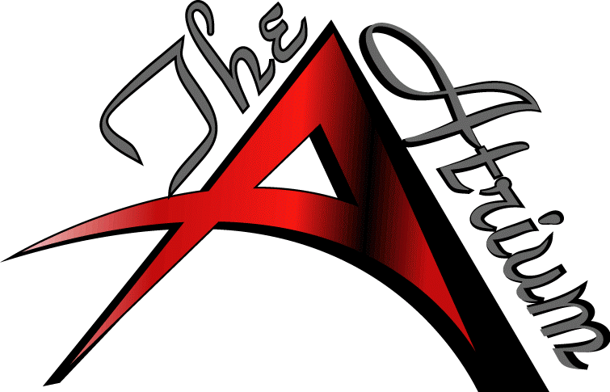
Diamond Room Floor Plan
Bar: Yes/No
Projector: Yes/No
Speaker: Yes/No
Client Name:_______________________ Event Date:_________ Arrival Time: __________ Event Type:________________
60” / 48” Tables: _____ # of chairs per table: ____ Hi boys: ____ 6ft tables: ____ Linen: _______

NOTES
___________________________________________________________________________________________________________________________________________________________________________________________________________________________________________________________________________________________________________________________________________________________________________________________________________________________________________________________________________________________________________________________

